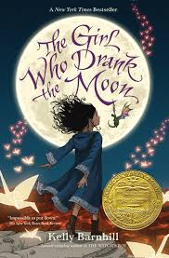
The Girl Who Drank the Moon by Kelly Barnhill
Curiosity House: The Shrunken Head
by Lauren Oliver

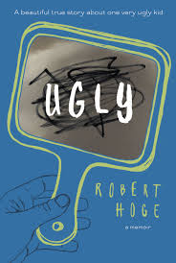
Ugly
by Robert Hoge

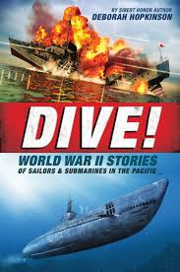
Dive! World War II Stories of Sailors & Submarines in the Pacific
by Deborah Hopkinson
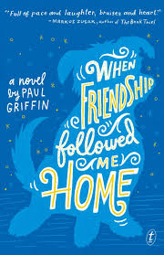
When Friendship Followed Me Home by Paul Griffin

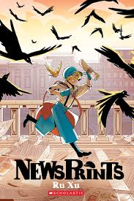
NewsPrints
by Ru Xu

Space Battle Lunchtime, Volume 1 by Natalie Reiss
Pax by Sara Pennypacker
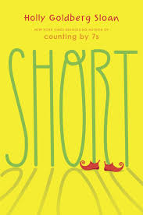
Short by Holly Goldberg Sloan
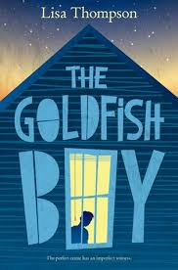
Goldfish Boy
by Lisa Thompson

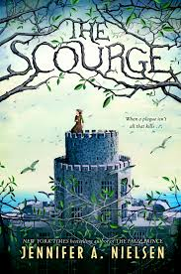
The Scourge
by Jennifer A. Nielsen

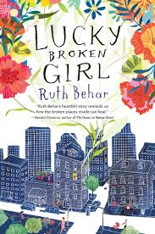
Lucky Broken Girl
by Ruth Behar

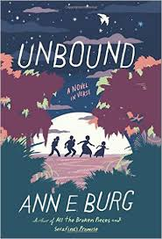

Unbound
by Ann E. Burg

